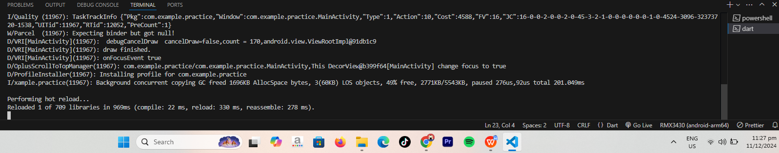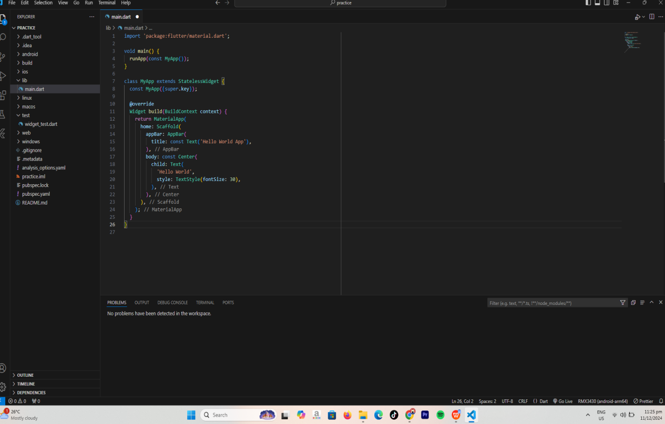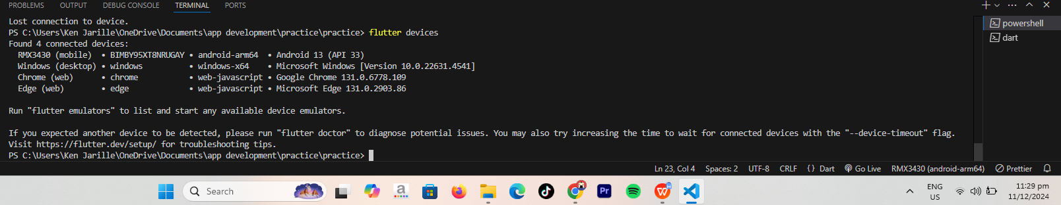SETTING UP THE EMULATOR   
  
  
  
  
  
  
  
  
  
  
  
  
  
  
  
  
HELLO WORLD CODE  
  
  
  
  
  
  
  
  
  
  
  
  
  
  
  
  
  
  
  
  
  
  
  
  
**saved the code then press r for hot reload**  
  
  
  
  
  
  
  
  
  
  
  
  
  
  
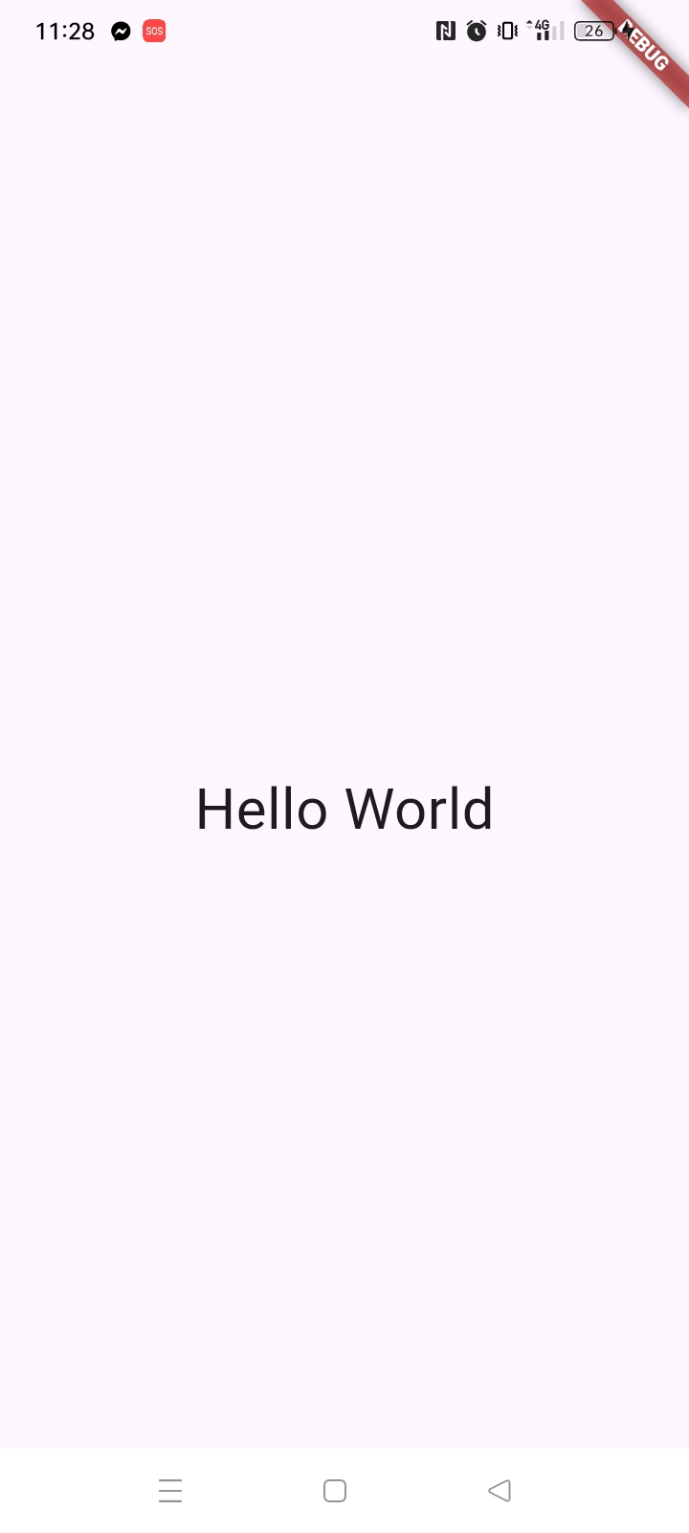AND HERE IS THE OUTPUT OF THE HELLOW WORLD